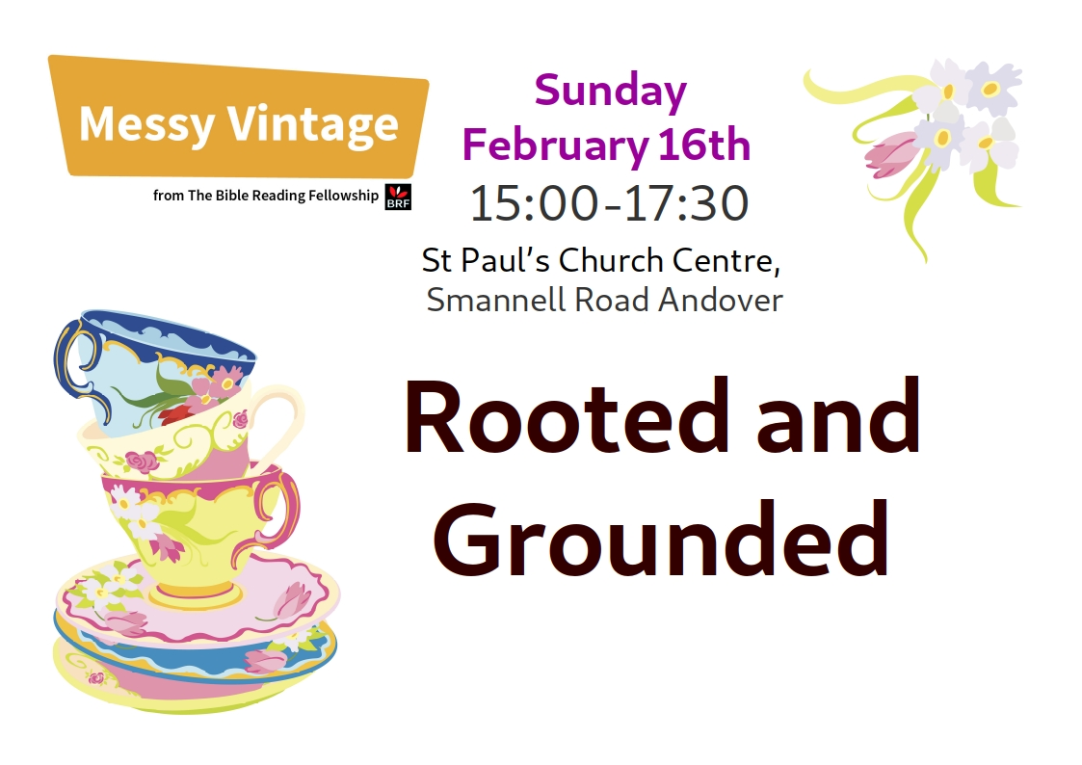
Well that’s it, it’s done! We have run Messy Vintage for the very first time. How did I feel before? Frankly? Very nervous! Would it work? Would people come?

In the end it went really well. Including the team, 17 people attended. Admittedly mostly church members but also a few others.

What words describe the experience for me?
- Fun
- Relief
- Joy
- Cake

We met after church to have lunch together and set up. To be honest, I think that we allowed more time for set up than we really needed but it was still good to spend time together before everyone arrived.
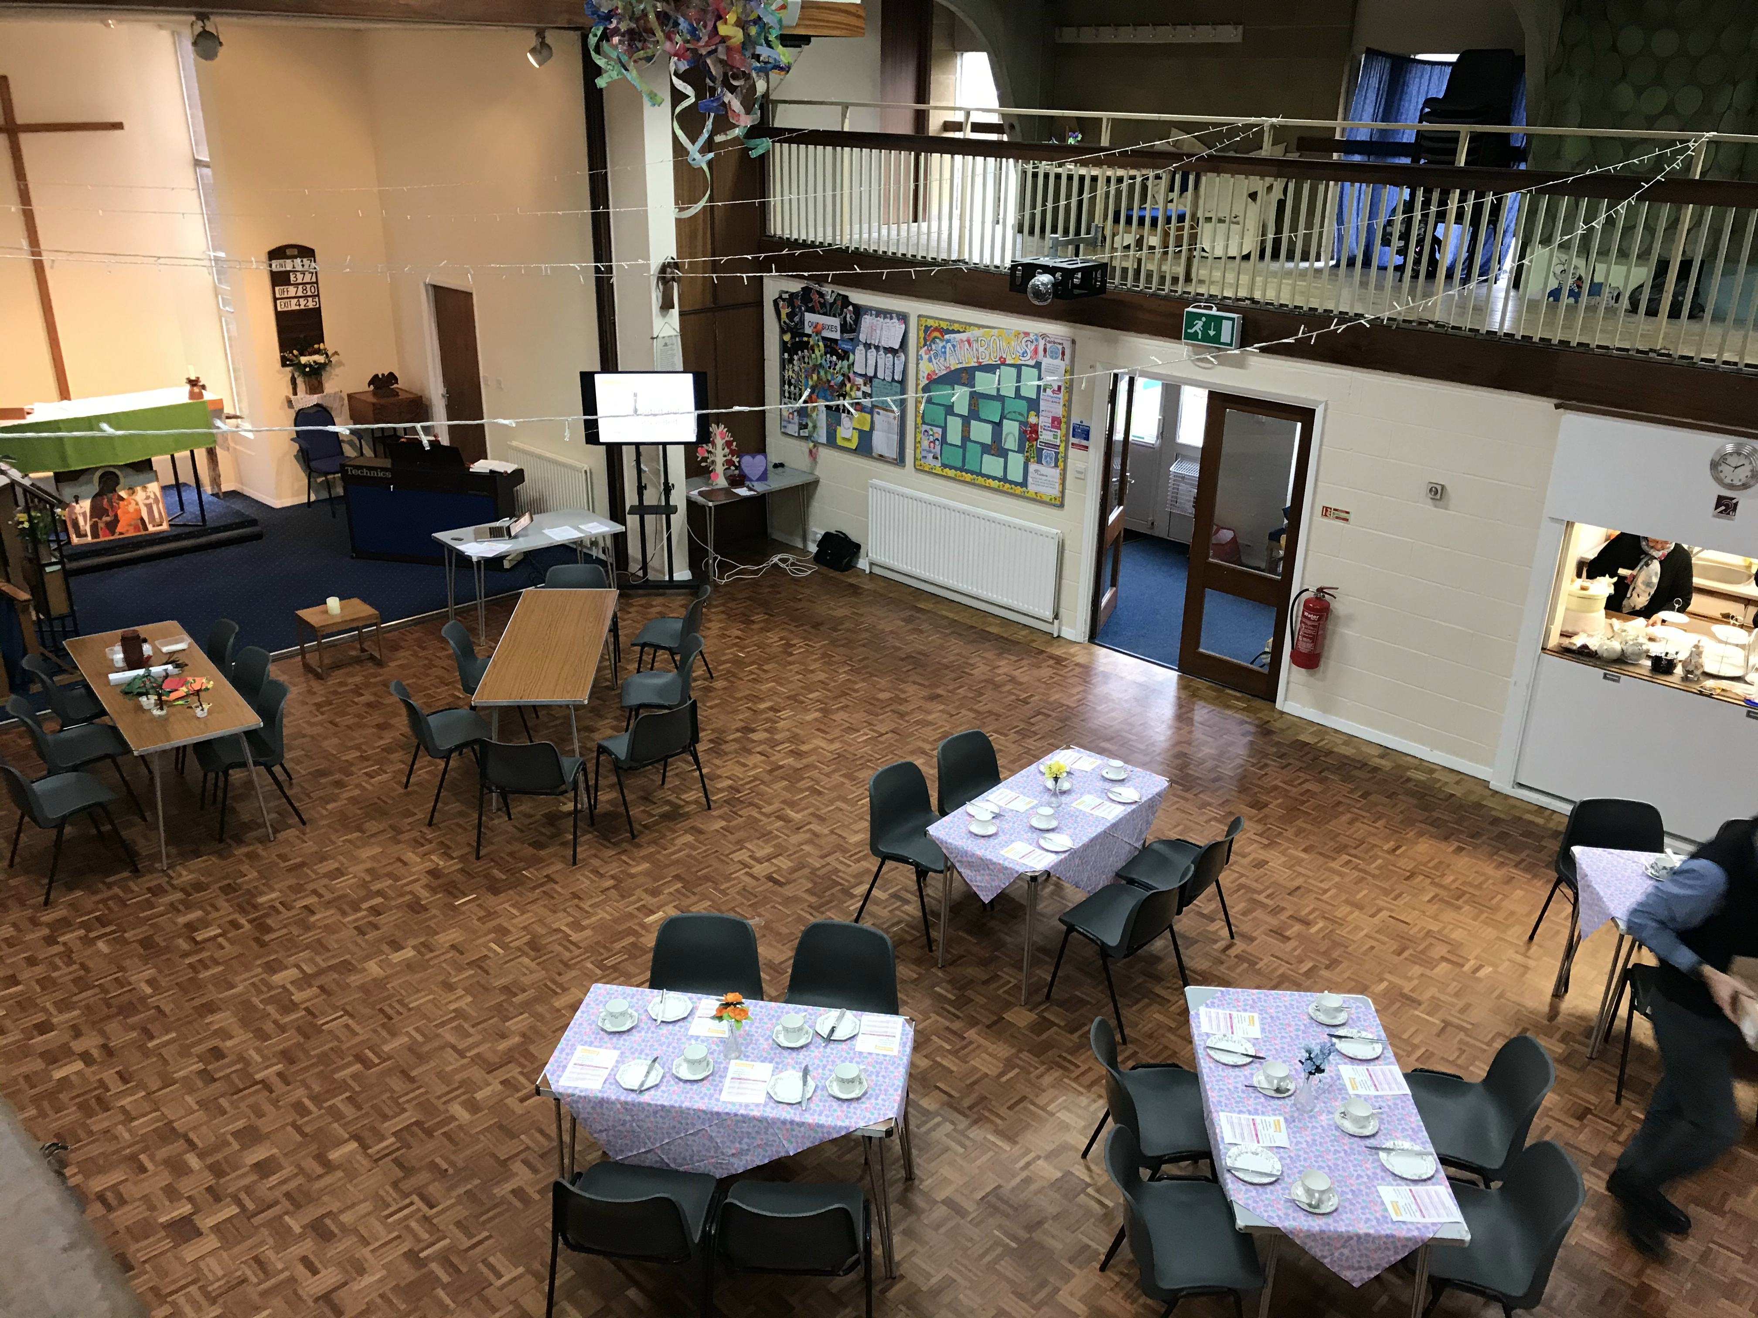
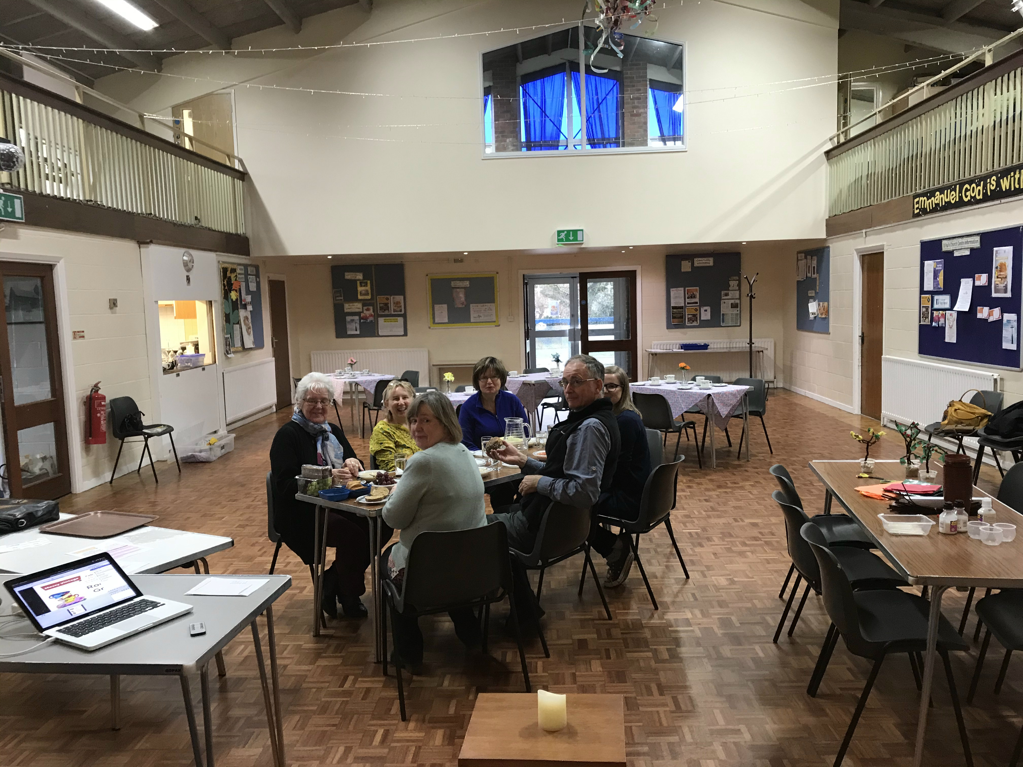

The craft
We made TREES! And very fine they were too. There were some unique interpretations of the tree theme that’s for sure.
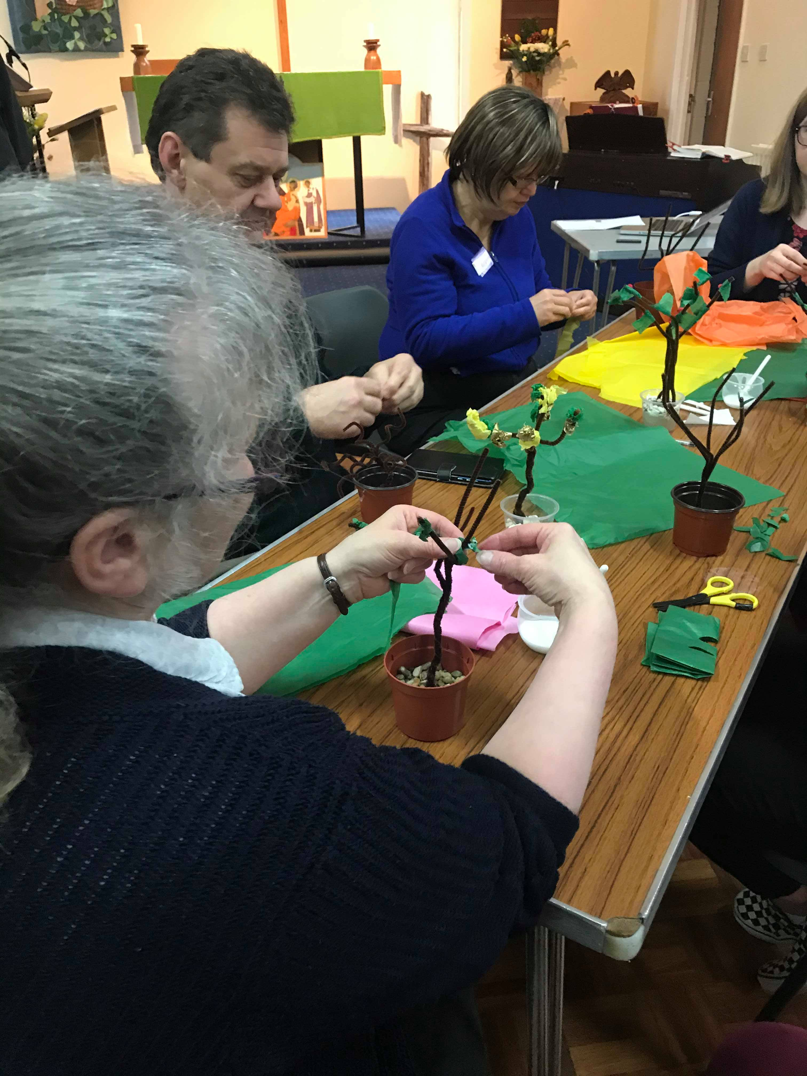
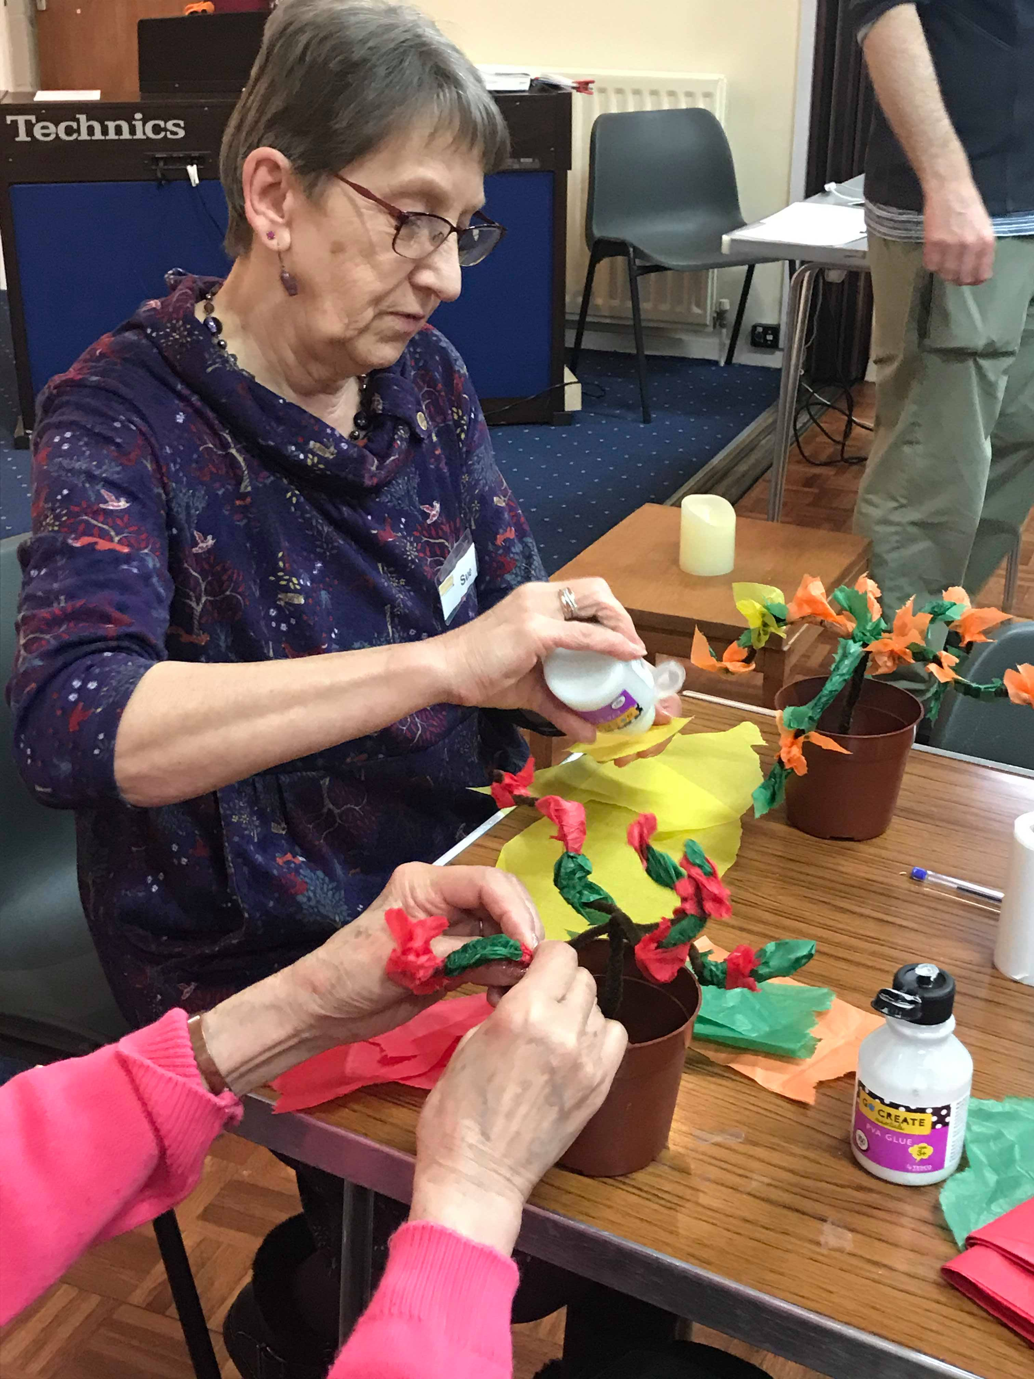
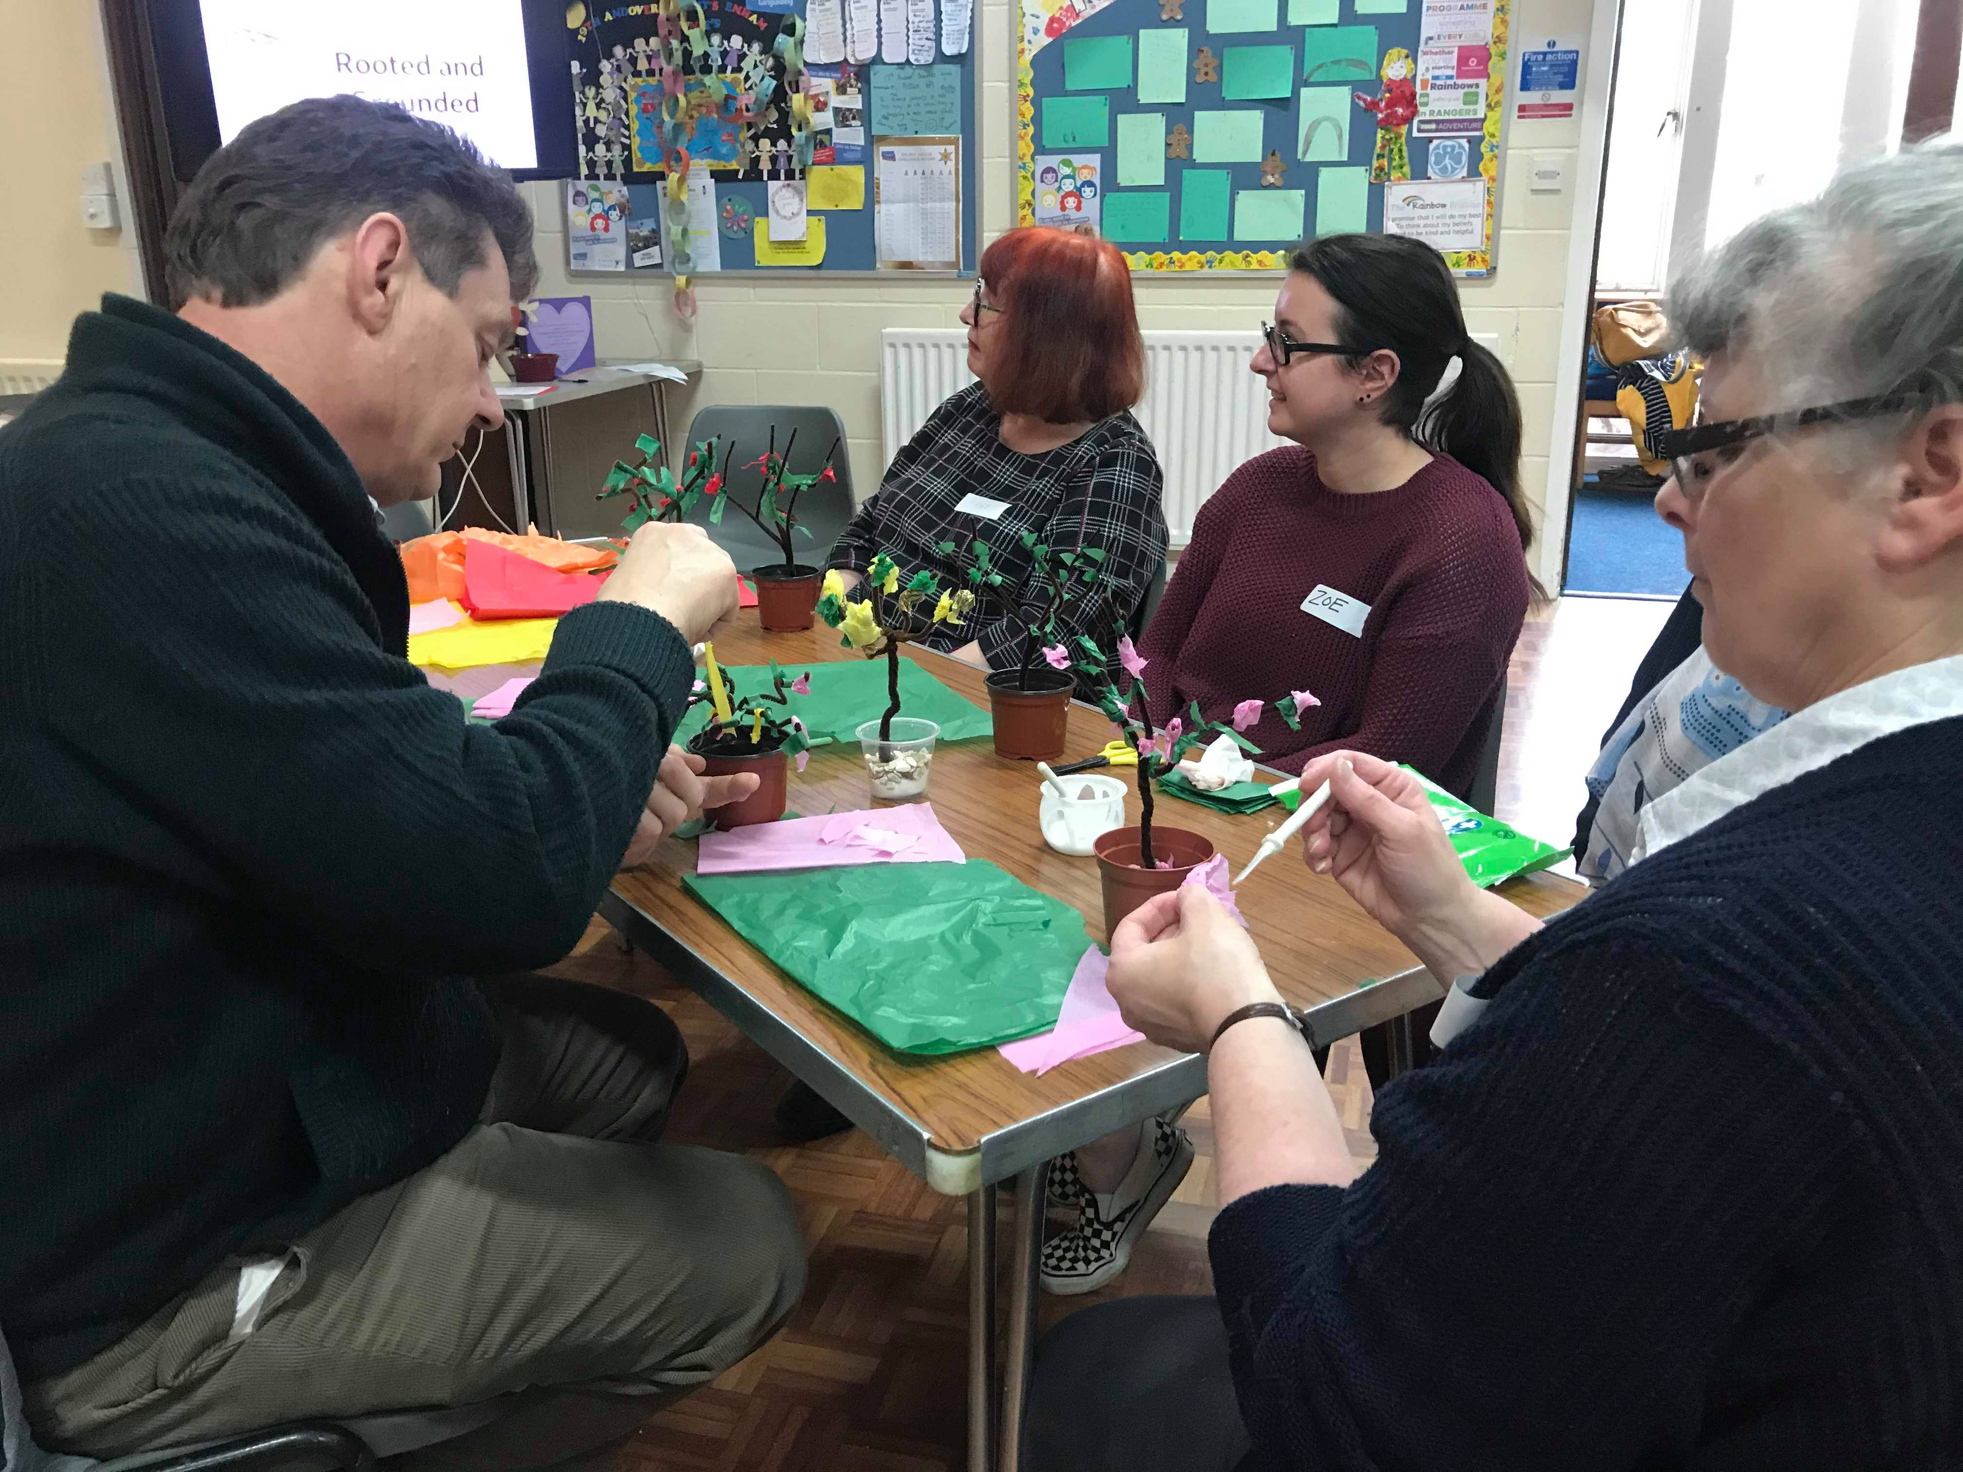

The celebration
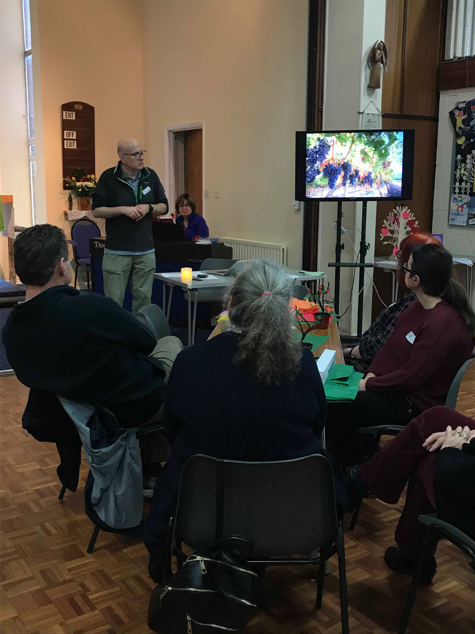
Reflecting on what it means to be rooted and grounded in God, we pondered how this means keeping in step with what he is doing and not frittering away our lives on trivialities. And from this place of safety being a blessing and shelter to others.
There was a discussion about our memories of trees, which gave me the excuse to show a home movie of me as a baby!
The discussion ranged from stories of dens and adventures in orchards, the effects of pesticides to memories of living near banana trees and being able to just reach up a grab one when they were hungry.
This was all intertwined with the singing of songs and the praying an almost accurate version of the Lord’s prayer!

The Tea!
The afternoon tea I think speaks for itself. Sandwiches and home made cake and scones with cream all served with Yorkshire tea. We scoured the local charity shops as well as our own lofts to bring together an eclectic collection of china cups and plates. It is definitely the case that tea tastes better in a china cup.
